

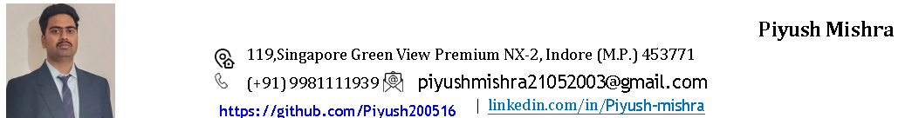

Career Objective: Aspiring Software developer currently pursuing a B.Tech degree with a strong foundation in Full Stack Web Development.
Piyush Mishra
119,Singapore Green View Premium NX-2, Indore (M.P.) 452001
(+91)9981111939

Academic Record:
Professional Qualification:
- Pursuing B.Tech. from AITR, Indore affiliated to RGTU Bhopal with specialization in CSE. (2024-27) (Average-55.6%)

Educational Qualifications:
- Diploma in Computer Science from Shri Vaishnav Polytechnic College, Indore. (2020-23)(Average-75.4%)
- HSC from Presidensi Public School (MP Board) with 60.5% in 2020.

Technical Skills:
Internship:
- Organization: PHYSICS WALLAH PVT. LTD
- Description: Worked on a Calculator App project during internship, contributing to development and gaining hands-on experience in real-world application development.
- Role: Project Development. Duration: 1 Month

Minor Project:
- Title: CampusFlow - Campus Management System
- Description: Developed a centralized, role-based campus management system to streamline placement processes, attendance tracking, and fee management, improving overall operational efficiency.
- Role: Full Stack Developer. Duration: 1.5 Month (01 Feb – 22 Feb 2026)

Other Project:
- Title: Learning Management System
- Description: A centralized platform for delivering, tracking, and managing education content, assessment, and learner progress across institutions or organizations.
- Role: Full Stack Developer. Duration: 1.5 Month (01 Nov -15 Dec 2025)

Certification:
- Certification of Physics Wallah Backend Development Course. (2024)
- Certification of Physics Wallah Full Stack Development Course. (2024)
- Certification of iNeuron Advance Application of Excel. (2024)

Rewards & Accolades:
- Received Internship offer Letter from Physics Wallah for Project contribution. (2024)
- Successfully completed freelance web development project for clients, delivering functional web solution. (2022-Present)

Co-Curricular Activities:
- Participated in a Hackathon, gaining experience in Problem-Solving and Team Collaboration. (2023-2025)
- Engaged in technical events and workshops to enhance practical knowledge. (2024-2026)
Strengths : Able to learn new technologies and concepts quickly.
Areas of Improvement : Self Impovement
Hobbies : Learning new technologies, Listening to Music
Areas of Interest : Traveling, Exploring New Places.

Personal Details:
Date of Birth : 02/03/2004
Gender : Male
Nationality : Indian
Marital Status : Unmarried Languages Known : Hindi, English Mother Tongue : Hindi
Father’s Name : Mr. Jaiprakash Mishra
Passport Details : Applied
References: Mr. Atul Bharat – Group Director-CDC, Acropolis Group of Institutions, atul@acropolis.in
Dr. Kamal Kumar Sathi, HOD of CSE Depatment , Acropolis Group of Institutions, kamalsethi@acropolis.in
Declaration: I hereby declare that the information furnished above is true to the best of my knowledge.

Date: / /
Place: Indore Piyush Mishra

